# Health & Wellness Tracker – Project Documentation

## Overview

**Project Name:** Health & Wellness Tracker

**Type:** Serverless Web Application

**Purpose:** Empower users to track health-related metrics such as sleep, hydration, exercise, mood, and nutrition with personalized feedback, secure access, and real-time updates.

**Status:** In Development

**Target Audience:** Individuals seeking to improve or maintain their health and well-being via digital self-tracking.

## Tech Stack

|  |  |
| --- | --- |
| **Component** | **Technology Used** |
| Frontend | React.js |
| Hosting | S3 + CloudFront |
| Backend | AWS Lambda (Node.js runtime) |
| API Gateway | Amazon API Gateway |
| Authentication | Amazon Cognito |
| Database | Amazon DynamoDB |
| Infrastructure IaC | AWS SAM CLI |
| Monitoring | Amazon CloudWatch |

## Security Features

* **Authentication:** Managed with Amazon Cognito User Pools.
* **Authorization:** Role-based access controlled via JWT tokens and IAM.
* **Data Flow Security:** HTTPS-encrypted API Gateway endpoints.
* **Data Isolation:** Per-user records stored with user ID as partition key.
* **Frontend Security:** Client-side form validation, input sanitation.

## High-level Architecture Diagram

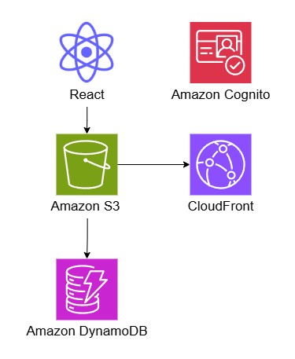

## Ideas

* Simple, cute, module design with clouds. Customizable.
* Mood, food, booked appointment logging.
* Food macros (Protein, Fat, Carbs) with extendable micros in the future.
* Sleep tracking with smart watch connection.